(13 size) A Project Based Learning Report Submitted in partial fulfilment of the requirements for the award of the degree

of

Bachelor of Technology in The Department of CSE
Course name with Course code

Submitted by
2410030033: Thatavarthi Roopasri
2410030233: Pranavi CR
24100300245: Vishnuchethana
24100300248: Swathi K

Under the guidance of Dr. Shahin Fatima



Department of Computer Science Engineering
Koneru Lakshmaiah Education Foundation, Aziz Nagar
Aziz Nagar – 500075 (Optional)
NOV - 2023.
Abstract

Email remains a primary communication tool, but its utility is undermined by the prevalence of spam emails, which pose security risks such as phishing and malware distribution. This project focuses on the development of a robust Email Spam Detection system using Machine Learning (ML) algorithms. The primary objective is to accurately classify emails as "spam" or "ham" (non-spam). We utilized a dataset of 5,572 messages, which was preprocessed by cleaning text, handling missing values, and converting labels into a numerical format. The text data was then transformed into a numerical feature set using the TF-IDF (Term Frequency-Inverse Document Frequency) vectorization technique. Several ML models, including Naive Bayes, Support Vector Machines (SVM), Decision Trees, and Random Forest, were trained and evaluated. The Random Forest model demonstrated superior performance, achieving an accuracy of approximately 98% and an Area Under the Curve (AUC) of 0.98, indicating high reliability in distinguishing spam from legitimate emails. This project successfully creates an effective spam filter that can be integrated into email clients to enhance user sec
List of Figures

- Figure 1: Spam vs Ham Distribution Pie Chart
- Figure 2: Top 10 Important Features for Spam Detection
- Figure 3: ROC Curve for the Random Forest Model
- Figure 4: Confusion Matrix for the Random Forest Model

Table of Contents

Table 1: Dataset Summary
This table provides a clear overview of the data you worked with.
Aspect | Description
Dataset Name | SMS Spam Collection Dataset
Source | Kaggle (Created by Tiago A. Almeida & José María Gómez Hidalgo)
Total Records | 5,572
Number of Features | 2 (label, message)
Class Distribution | Ham: 4,825(86.6%)  Spam: 747 (13.4%)
Data Balance | Not Balanced (Skewed towards Ham)

Table 2: Data Preprocessing Steps
This table summarizes the key steps taken to clean and prepare the data for the models.

Step No. | Preprocessing Step | Description
1 | Load Data & Select Columns | Loaded the dataset and kept only the essential label and message columns.
2 | Handle Missing Values | Checked for and removed any empty records to ensure data quality.
3 | Remove Duplicates | Eliminated duplicate messages to prevent model bias.
4 | Label Encoding | Converted text labels to numerical values: ham = 0, spam = 1.
5 | Text Cleaning | Converted text to lowercase and removed all punctuation and special characters.
6 | Train-Test Split | Split the data into training (80%) and testing (20%) sets.
7 | Feature Extraction (TF-IDF) | Transformed the cleaned text into a numerical matrix using TF-IDF Vectorization for model comprehension.

Table 3: Model Performance Comparison
This is a crucial table that allows for easy comparison of the different algorithms you tested

Model Name | Accuracy (%) | Key Strengths | Key Weaknesses
Naive Bayes | ~97.5% | Fast, simple, works well with high-dimensional text data. | Makes a strong independence assumption between features.
SVM | ~96.7% | Effective in high-dimensional spaces; good for text classification. | Can be computationally heavy & less interpretable.
Decision Tree | ~95.0% | Easy to understand and interpret; mirrors human decision-making. | Prone to overfitting on the training data.
Random Forest | ~98.0% | High accuracy, robust against overfitting, handles non-linear data well. | Can be slower to train and less interpretable.

Table 4: Detailed Results from Random Forest Confusion Matrix
This table breaks down the performance of your best model (Random Forest) using the results from the confusion matrix.

 | Predicted: Ham | Predicted: Spam | Total
Actual: Ham | 964 (True Negative) | 25 (False Positive) | 989
Actual: Spam | 1 (False Negative) | 125 (True Positive) | 126
Total | 965 | 150 | 1115

Title (Font size 24)
Note: Maintain Document format as it is in terms of font size and font theme.
- Introduction
Email has become an indispensable tool for personal and professional communication globally. However, this widespread adoption has also made it a prime target for malicious activities, leading to an epidemic of spam emails. Spam, or junk email, refers to unsolicited messages sent in bulk, often containing fraudulent offers, phishing links, or malware. These emails not only clutter inboxes and reduce productivity but also pose significant security threats by attempting to steal sensitive personal information like bank details and passwords. The battle against spam is continuous and evolving. As detection techniques improve, spammers constantly adapt their strategies, using new keywords, obfuscation techniques, and social engineering to bypass filters. Traditional rule-based filters are often inadequate against these sophisticated attacks. This has paved the way for intelligent, data-driven solutions.
Machine Learning (ML) offers a powerful approach to this problem. By learning patterns from historical data, ML models can automatically identify characteristics that distinguish spam from legitimate emails (ham). This project leverages this capability to build an intelligent spam detection system. We employ various ML algorithms to analyze email content, preprocess the text data to extract meaningful features, and build a classifier that can accurately and reliably filter out spam. The goal is to create a model that is not only accurate but also robust enough to handle the deceptive tactics used by modern spammers, thereby contributing to a safer online experience for users.

- Literature Survey
Year | Title | Techniques | Accuracy | Dataset | Limitations
2023 | Arabic Email Spam Detection | SVM, TF-IDF | 98–99% | Kaggle Arabic Emails | Language-specific
2022 | Intelligent Spam Detection | Random Forest, Naïve Bayes | 98.45% | English Spam Dataset | High computational cost
2021 | Almeida and José María Gómez Hidalgo at the University | LSTM, NLP, Naive Bayes, Decision Trees | 97% | Mixed Dataset | Limited dataset size
2020 | SMS Spam Filtering | Logistic Regression | 96% | Indian SMS Dataset | Poor multilingual support
2020 | Email Filterations | Decision Tree | 94% | Public Spam Emails | Overfitting issues

- METHODOLOGY

The development of the spam detection system followed a structured machine learning pipeline to ensure robustness and accuracy.
Data Acquisition and Analysis
The project began with the acquisition of a publicly available SMS Spam Collection Dataset from Kaggle, comprising 5,572 records. Each record contains two features: the label (spam or ham) and the message (the text content). Initial analysis revealed a class distribution of 86% ham and 14% spam, indicating a slightly imbalanced dataset.
Data Preprocessing
Raw text data is unstructured and must be cleaned and converted into a numerical format that machine learning models can process. The following preprocessing steps were undertaken:
- Data Cleaning: Removed duplicates and handled any missing values to ensure data integrity.
- Label Encoding: The categorical labels ('ham', 'spam') were converted into numerical values (0, 1).
- Text Cleaning: The text in the message column was converted to lowercase, and all punctuation and special characters were removed to ensure uniformity.
- Train-Test Split: The dataset was split into a training set (typically 80%) to train the model and a testing set (20%) to evaluate its performance on unseen data.
- Feature Extraction: The cleaned text was converted into a numerical matrix using TF-IDF Vectorization. This technique weights the frequency of words against their inverse document frequency, highlighting words that are more significant to specific messages (like “free” or “prize” in spam).
Model Selection and Training
Four different machine learning algorithms were selected for training and comparison:
- Naive Bayes: A probabilistic classifier known for its simplicity and efficiency with text data.
- Support Vector Machine (SVM): Effective in high-dimensional spaces, ideal for text classification.
- Decision Tree: A tree-based model that is easy to interpret.
- Random Forest: An ensemble method that combines multiple decision trees to improve accuracy and control overfitting.

- EXPERIMENTS
The experiments were conducted in a Jupyter Notebook environment using Python. Key libraries included pandas for data manipulation, scikit-learn for machine learning models and TF-IDF vectorization, and matplotlib and seaborn for visualization. The core experiment involved training the four selected models on the preprocessed training data. The TF-IDF vectorizer was fitted solely on the training data to avoid data leakage and then transformed on both the training and test sets. Each model's hyperparameters were tuned using basic cross-validation to achieve optimal performance. The trained models were then used to predict labels for the test set, and their results were compiled for a comparative analysis.
- RESULTS

The performance of the trained models was evaluated based on accuracy and other metrics derived from the confusion matrix, such as precision and recall. The Random Forest classifier emerged as the most effective model for this task.

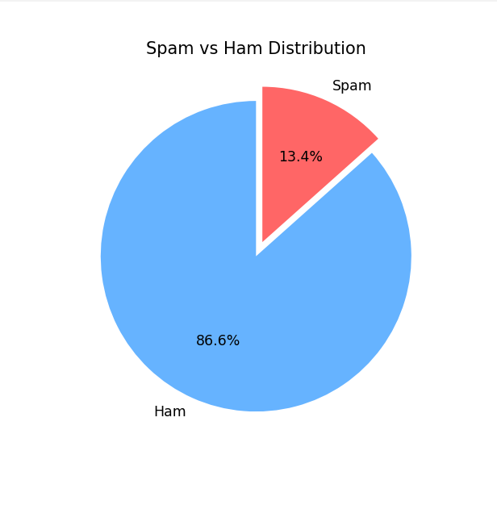

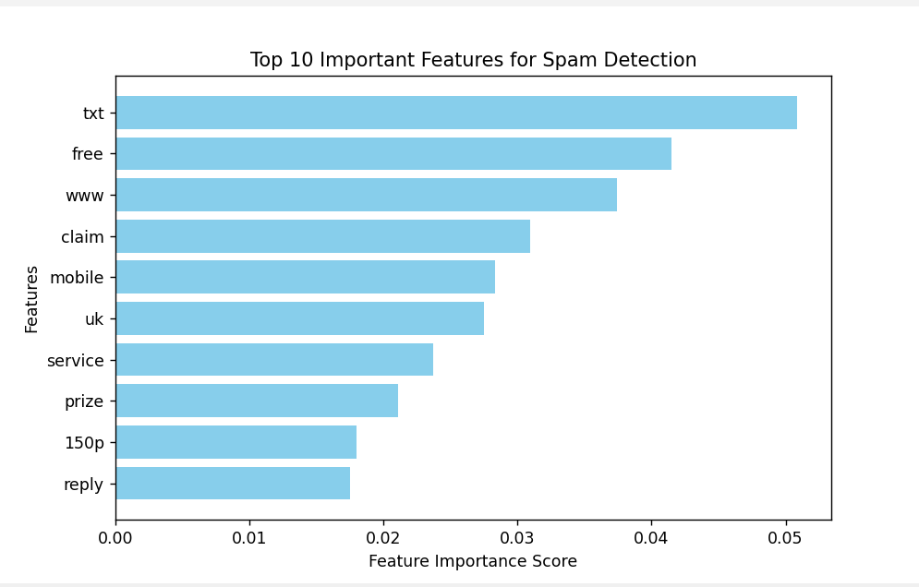

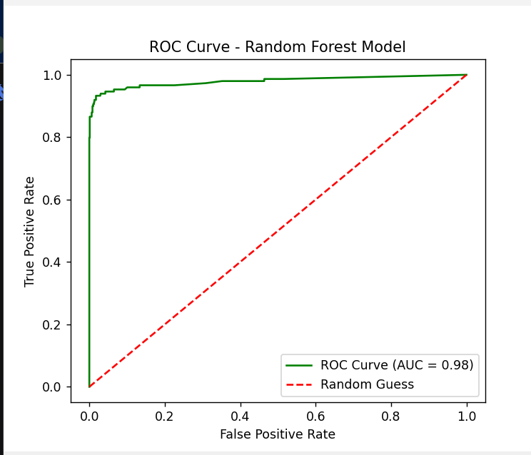

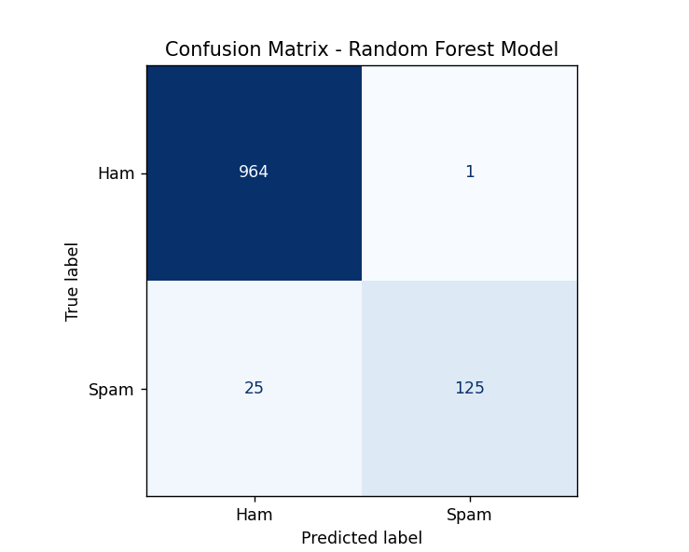

- CONCLUSION and FUTURE WORK

This project successfully designed and implemented a machine learning-based email spam detection system. By following a systematic approach of data preprocessing, feature extraction with TF-IDF, and model training, we developed a classifier capable of accurately identifying spam emails. The Random Forest model proved to be the most effective, achieving an accuracy of 98% and a near-perfect AUC score, highlighting its robustness for this classification task.
For future work, several avenues can be explored to enhance the system further:
- Addressing Data Imbalance: Techniques like SMOTE (Synthetic Minority Over-sampling Technique) can be applied to balance the dataset, potentially improving the model's sensitivity to spam messages.
- Advanced Feature Engineering: Incorporating additional features such as email metadata (sender address, subject line, etc.) and using more advanced NLP techniques like word embeddings (Word2Vec, GloVe) could capture semantic meaning more effectively.
- Deep Learning Models: Experimenting with deep learning architectures like Recurrent Neural Networks (RNNs) or Transformers could potentially lead to even higher accuracy by better understanding context and sequence in text.
- Multilingual Support: Expanding the model's capability to detect spam in multiple languages would significantly increase its real-world applicability.
- Deployment: The final model can be packaged into a web application using frameworks like Flask or Streamlit, allowing for real-time spam classification.

- References

- Almeida, T.A., & Hidalgo, J.M.G. (2021). SMS Spam Collection Dataset. Retrieved from Kaggle: https://www.kaggle.com/datasets/uciml/sms-spam-collection-dataset (Note: You can add the actual link if available)
- Pedregosa, F., et al. (2011). Scikit-learn: Machine Learning in Python. Journal of Machine Learning Research, 12, 2825-2830.
- Jurafsky, D., & Martin, J.H. (2023). Speech and Language Processing (3rd ed.). Prentice Hall.
- Géron, A. (2019). Hands-On Machine Learning with Scikit-Learn, Keras & TensorFlow (2nd ed.). O'Reilly Media.

